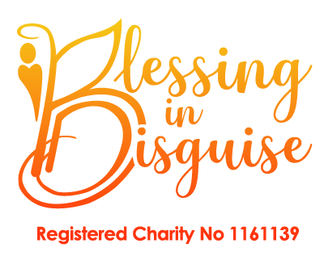 | Nomination Form  2024 | 

Decisions are made on an individual basis.
Name of Child:
Date of Birth:  Address: | __________ Name of Parent(s)/Guardian(s) _______________________________
Post Code: | ___________ Email__________________________________________________
Tel. Home: |  | Mobile:

Details of nominator (person making the nomination if a third party)

Name & contact number:
Please specify the medical condition or injury suffered by the nominee
Please describe the difficulties the nominee has faced due to their condition
(This information will remain confidential if required)
Please describe why you feel that the nominee deserves a place on ‘Santa in July’
(Please continue on a separate sheet if necessary)

Return completed form to:
OFFICE USE ONLY: Initials
Blessing in Disguise | Date Received:
Lilford House | Method: | Email / Post / Hand.Del.
St. Helens Road | Director Decision: | Approved / Declined
Leigh | B.I.D. Ref: | SIJ2024
WN7 4HG

Or Email to: blessingsindisguisecharity@gmail.com or Phone 01942 316113

Blessing in Disguise (BID) is a company limited by guarantee and registered in England.
Registered Company No: 8790053 Registered Charity No: 1161139
Registered Office: Lilford House St Helens Road, Leigh, WN7 4HG

